Two weeks in Dalseter, Norway (by Vivienne Brown)
Back again to Norway, wonderful Dalseter. We had a lovely time – two weeks for Ebony and Vivienne, plus a week for Harry. But it wasn’t quite as we had planned!
Ebony and I had previously skied with the visually impaired group in Finland, which is a great destination for them in that it’s an organised package holiday, so planning is simple, tracks are great, terrain is rolling and there are lots of cafes en-route for lunchtime stops. Dalseter was always going to be more challenging in every way, but the practicalities of planning a skiing holiday during COVID times, together with Pam Curwen’s links to the hotel made it the best option. We committed to the trip and organised flights in mid-November, and then had to put everything on hold for a couple of months as Omicron took over and everything became uncertain again. Against all the odds, four visually impaired skiers, three instructors and seven guides/non guiding friends made it to Dalseter. Harry joined us for the second week.

Dalseter had considerably less snow than usual, particularly off track, but despite the reduced snow cover, it was as lovely as ever.
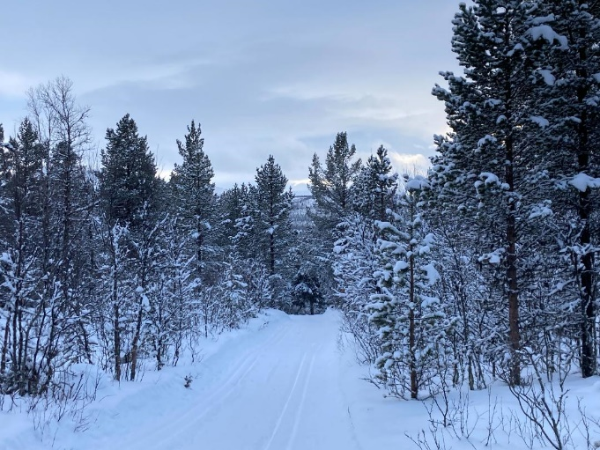
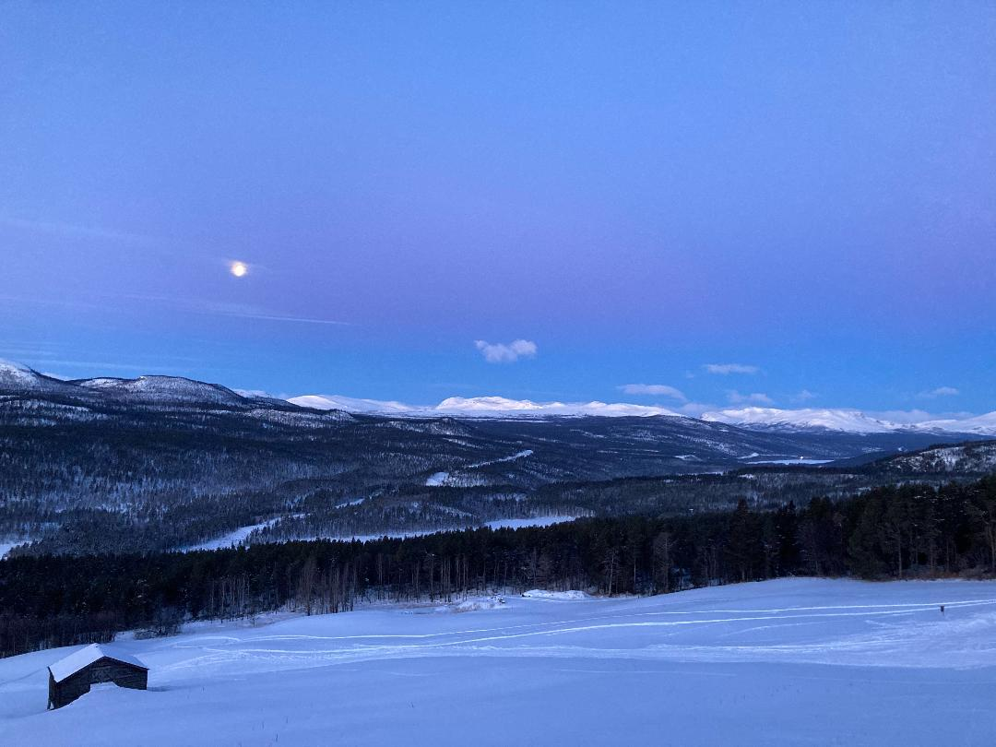
The four visually impaired skiers were of very different abilities. We hadn’t broken it to them beforehand that every route back to the hotel involved a substantial downhill. But the ratio of instructors and sighted skiers meant we could adapt to everyone’s needs and we had some good skiing.

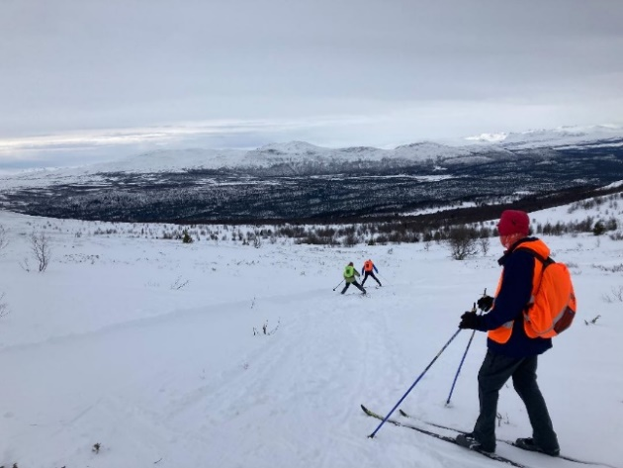
For me the best day out was with Rachel, who has tunnel vision. We made it up and down to Bingsbu, despite there being no tracks anywhere near the hut and it being decidedly windy and chilly. The descent in the biting wind felt decidedly hairy to me! I always preferred skiing with metal edges but, putting aside my prejudices aside, I had hired track skis for the week. I was in awe of Rachel who took it all in her stride and had no more falls than the rest of us during the day.

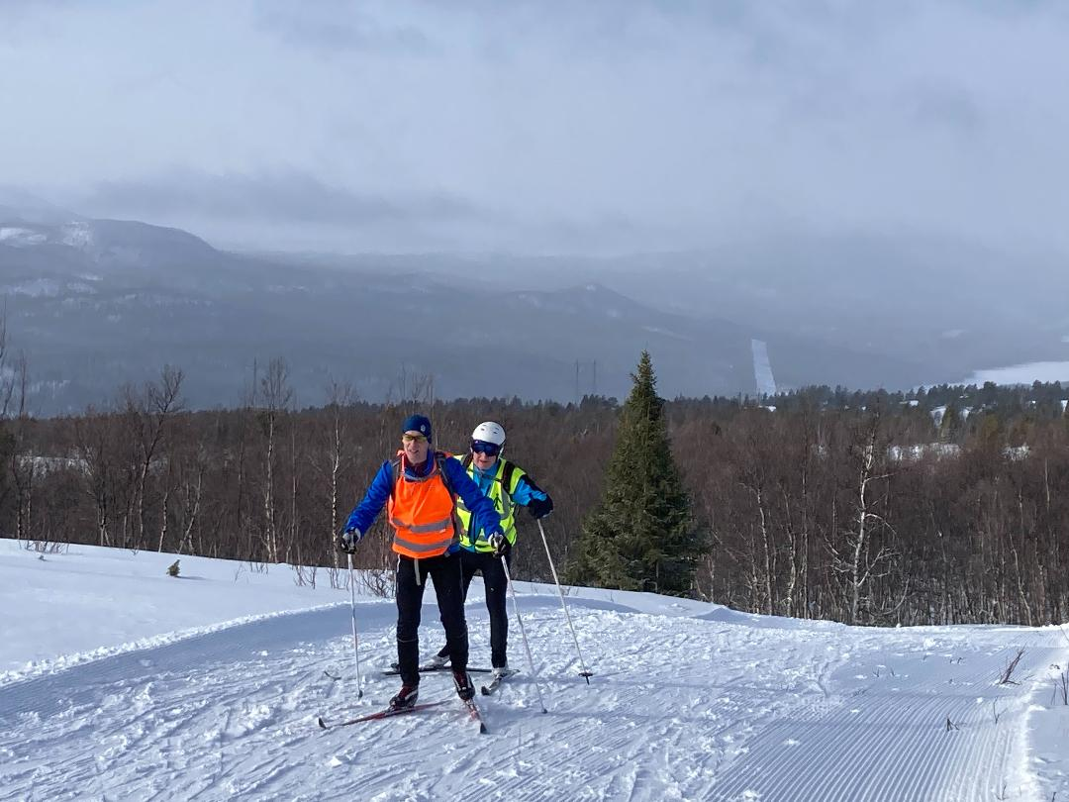
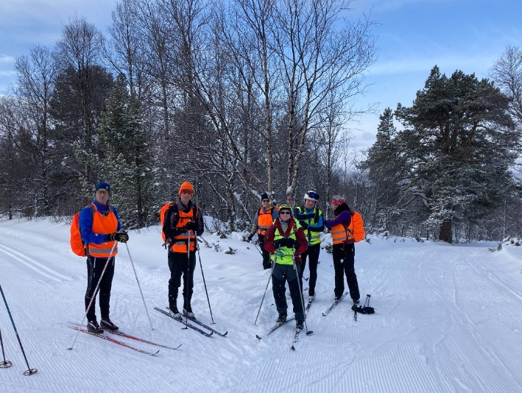
All went to plan until the end of Wednesday of the first week. But the trip changed for me on the Thursday of the first week when Ebony, and one of the others in our group, tested positive for COVID. When we arrived, we were told that Grethe and one other in the hotel had tested positive so, despite the Brits wearing masks and keeping in our social groups away from others it was no real surprise that it spread. I had an hour or so of gulping at the prospect of having to isolate in a room with Ebony for an indefinite period, so was relieved to find that Norwegian recommendations were only four days isolation and that there were no problems with going outside. I then spent the next few days offering TLC and getting familiar with the local livestock on our gentle outings, alongside a few hours each afternoon of fantastic, but solo skiing. Harry arrived during this period, so we waved at each other from a distance and he joined our table of rapidly diminishing spaces.
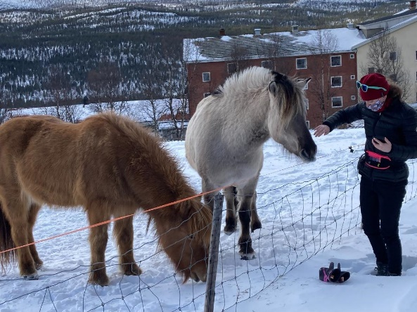
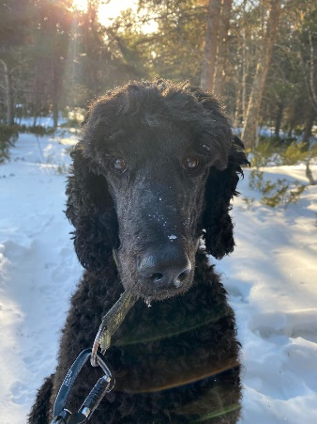
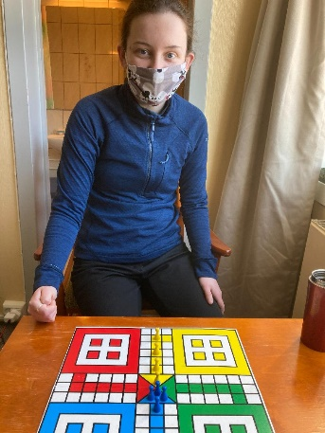
The COVID situation rather put into question our second week of skiing, with the GB Nordic programme. Pete and Pam Curwen, who’d been leading us on the first week, were left with something of a logistical nightmare. At one point it looked as if they’d only be joined by Stefan for the next week – though Dagmar and Rosie did come (though Rosie also ended up testing positive after a few days).

In the end, seven of our group succumbed to the virus, including me five days after Ebony. By that time we had a COVID positive WhatsApp group which meant we could socialise together and have our own gentle walks in the sun. Some of you have met James and Clare de Courcy and Alan Gilchrist in the past, all of whom proved to be good company.

We can’t speak highly enough of Pam and Pete Curwen, who somehow negotiated their way through the logistics of increasingly poor snow, the organisation of the GB Nordic 2 group alongside the VI group and tending to the needs of an increasing number of people needing food, etc, with great kindness and good humour. The remainder of our group left at the end of the second week and Ebony spent a fantastic day out with Pam, getting to and from Bingsbu in less than two hours in the morning and then heading out off-track in the afternoon. By that time I was managing a little gentle skiing, although still taking the lift upstairs at all times!
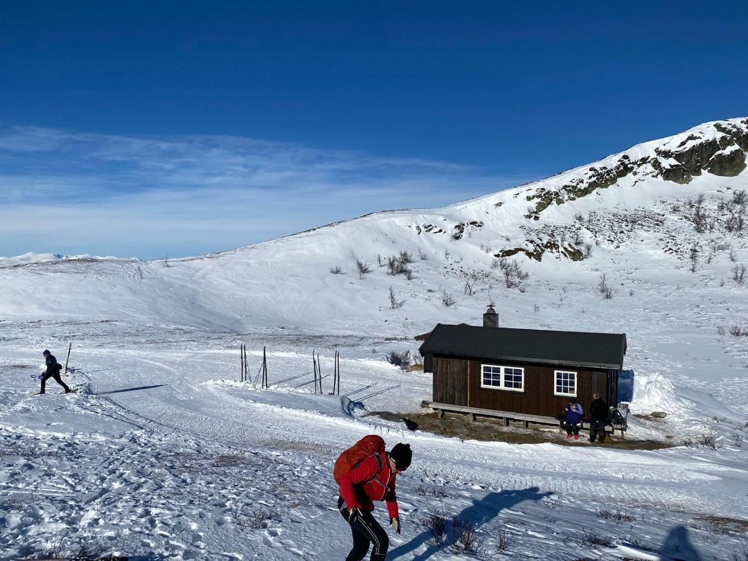
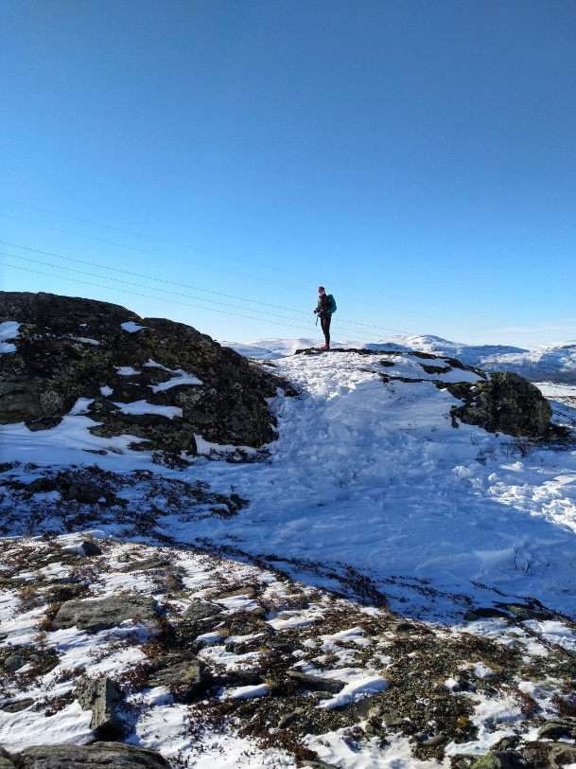

So, on Saturday 5th March, we sadly left to catch the train at Vinstra, where we waved goodbye to Harry as we headed south and he headed north to the Lofotens, with his camera – virus free.

Would we have gone had we known we were walking into a COVID den? Probably not! But are we glad we didn’t know? – definitely. It was a good trip with many happy memories and no regrets about going. We already have provisional dates for next year’s visually-impaired trip in the diary!

Vivienne Brown

